EXPRESSIONS

Healing Through Verse

Laurel Hall

Copyright © 2012 by Laurel Hall
Loveland, CO
All rights reserved

No part of this book may be reproduced in any form or by any electronic or mechanical means, including information storage and retrieval systems, without written permission from the author, except in the case of a reviewer, who may quote brief passages embodied in critical articles or in a review.

Expressions

Some of the poems
written here
are filled with
pain and sorrow.
Other’s contain
hope and joy –
a promise
for tomorrow.
Still others speak
of life and more,
of gardens, plants
and flowers;
questions, thoughts
and memories
which did my soul
empower.
This expression
of my inner self
you take with you today,
hopefully will speak to you
in a very special way.
It is my wish
that you will find
some peace –at least a start;
release from pain
that may have settled
deep within your heart.
Laurel Hall

Poems
Of
Pain

Pain

Lord, this little girl inside of me
is longing to be free.
I hear her crying, pleading,
oh, so desperately.

She has suffered so much pain,
her anguish I can feel.
The fear, the hate, the suffering,
too real, Lord, much too real.

The tears fell hot upon her face,
they wet my own today.
Though years pass, time can’t erase
those memories away.

The child is crying out, Lord,
for one who understands,
for one to love and hold her -
to take her little hand.

Lord, take this little girl
so lonely and forlorn.
Surround her with Your love,
like a blanket, keep her warm.

Until she stops her crying, Lord,
and knows Your love is real.
Make her feel secure and safe,
at peace, at last, and healed.

Stolen Childhood
Part I

Only four, so young,
so trusting, so innocent.
They lived next door,
and down the street -
the neighborhood boys.

One day, a neighbor boy
asked her if she would like to
go for a walk.
He led her to an old shack.
When they went inside,
other boys were there.

They took off her clothes,
and had her lie on the ground.
As others held her down,
each had their way with her,
one by one.

They all laughed.
She did not understand.
She had never felt
these sensations before.
Don’t tell your parents,
They will whip you.
It was her fault
for going with him.

Each time she went outside
the boy was waiting.
When she said “no”,
he threatened to tell her parents.
She felt trapped.
Before long,
she went willingly.

Poems
Of
Reflection

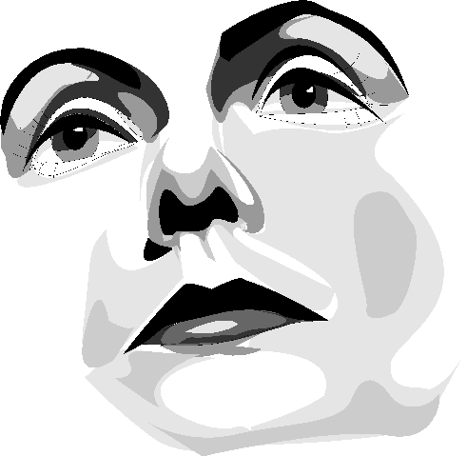

Thoughts

Thoughts unuttered
in our hearts,
painful thoughts
which are a part
of our very being,
must be spoken,
must be heard,
another soul
must hear these words
for us to be free
of their power.
Unspoken, they fester,
and become
an abscess deep,
and one day
into our conscious being
they will seep,
and bring us pain.

Grief

Death does part the curtain
and let the wayfarer by,
then closes the portal quickly
lest viewed by mortal eye
the promised land.

Grief, that bittersweet pain
that throbs within our breast.
Uncried tears, unuttered thoughts,
our body weary and longing for rest
that will not come.

Sorrow so deep, loss too real -
the emptiness which engulfs the home.
Well-meaning friends come by to help,
but mourning’s a time we live through alone,
we live through alone.

Our sadness is not for the one
who has passed through the door called death.
It is for us that our heart cries out,
for the pain that we feel, for the void that is left
in our lives.

Yet, as time goes by you laugh again,
for joy is also a part of life.
But always there within your heart are
memories you shared as husband and wife
and the love you knew.

Poems
Of
Happiness

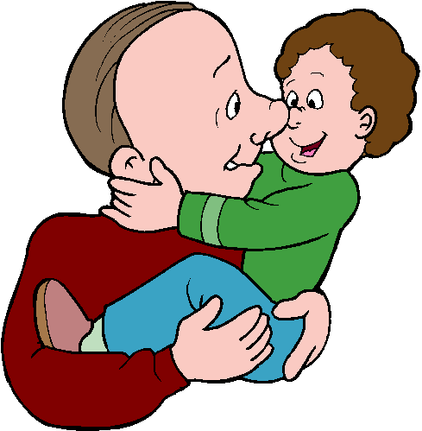

Acceptance

What happiness
acceptance
brings.
Self doubts
are cast aside.
Pure joy
does fill
my being.
In my heart
peace
does
reside.

Joy

It isn’t money.
It isn’t fame.
Not even
education.
To love and
be loved,
to know
you are special;
to have
a loving family,
neighbors,
and
friends,
folks
with whom
to share
laughter
and
tears -
this
is the
greatest
joy
in life.

Poems
Of
Meditation

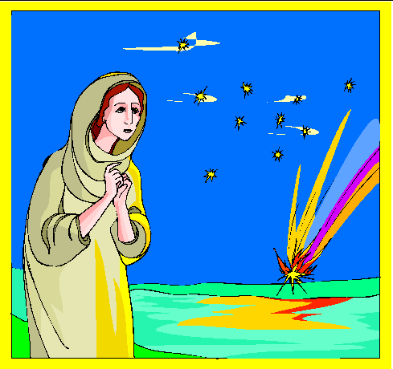

Arrogance

I wanted God to do things my way,
to show his face, to prove himself to me.
I prayed and prayed and waited for his power,
that I might heal the sick and make the blind to see.

I wanted to be God, to be his equal, -
not a mere human, no this was not for me.
But, he would not do things my way,
so I refused Him and all His words were lies to me.

There is no God, I cried, who would let his people suffer.
There is no God, no there is only me.
Only me I can depend on -
and in my blindness, I stumbled on in agony.

Hurt and heartache I brought upon myself.
Hate and tension through my being flowed.
No reason for living, continual strife,
questions unanswered, what purpose this life?

The pain grew until I could stand it no longer,
God, I cried out, You win, don’t You see?
I’ve tried it my way, but my life is in pieces,
a shambles is all that I have left of me.

For the first time in my life that I can remember,
a beautiful calm fell over my heart.
old hurts and hostilities, hatred and tension,
were all wiped away and that was the start.

This joy that is mine, this love that we share,
can be yours anytime, anyplace, anywhere.
Confess to your God that you are lost without him,
That you need his help – you are tired of sin.

Are You There?

Are you there, God?
Do You hear my prayer?
Do You really care
about me?

I get to feeling so low, God,
I don’t know where to go, God,
or where to turn, God,
but to You.

I long for your comfort,
the peace that You bring
which can make my heart sing
songs of joy.

I long to be free
from the things of this earth,
to be innocent, gentle and kind.

Oh, God, do You mind that
I ramble like this?
Do you care? Are you there?
Are you mine?

