WORKBOOK

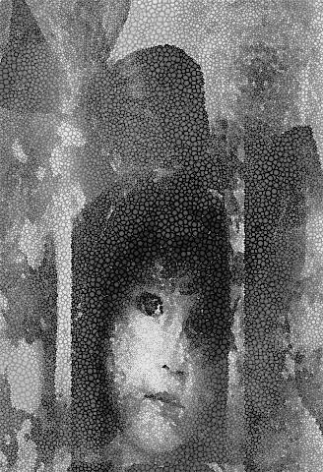

NAME ________________________________________________________
DATE_________________________________________________________
SCHOOL_______________________________________________________

Copyrighted 2013
All rights reserved
Laurel Hall
Loveland, CO

1. Define child abuse.

2 What are some of the myths surrounding child sexual abuse?
.

3. Name the four basic types of child abuse.

4 What is the most prevalent type of child abuse in the United States?

5. How many children are abused each year?

6. What percent of sexual abusers are male?

7. What percent of prison inmates were abused as children?
Male?
Female?

8. What percent of children are sexually abused each year?
Girls?
Boys

9. Define incest?

10. What should be done if there is a case of incest in a family?

11. What are some of facts surrounding incest?

12. Define child sexual abuse?

13. Describe the various types of sexual abuse.

14. What are some of the myths surrounding sexual abuse?

15. What are the sign/symptoms that a child is being sexually abused?

16. What are some of the emotional consequences of sexual abuse?

17. What can be done to help a child that has been sexually abused?

18. Define child physical abuse?

19. What are some of the visible signs of child physical abuse ?

